**Food Pickr Interface Sketch & Notes**

Sebastien Savard, Yucheng Jiang, Evan Bakkal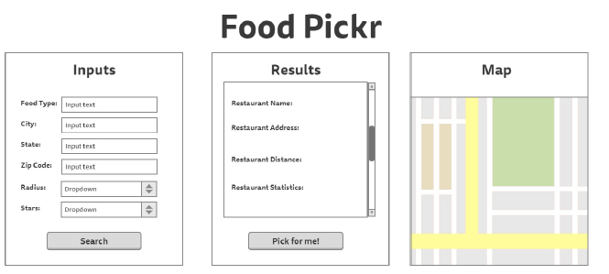

* Functionality
  + The service will only be on a single web page
  + Users will input text criteria, choose from dropdown boxes for restaurants in the “Inputs” box
  + Results will be outputted to “Results” and “Map” box
  + “Results” box will be able to scroll up and down to view list of restaurants
  + “Map” box will be navigated the same way Google maps is (It is the same API after all) by dragging and clicking mouse
* Design/Colors
  + All background/foreground designs/colors may be changed based on user study results
  + Uncluttered and appealing UI will be presented to user in order to avoid confusion